### GUJARAT TECHNOLOGICAL UNIVERSITY (GTU)

**Ahmedabad**

##### G H Patel College of Engineering and Technology

A Report On-

##### “Snake Robot”

Under subject of

DESIGN ENGINEERING – 1A

B. E. II, Semester III MechatronicEngineering

###### Submitted by Group ID: 182502

|  |  |  |
| --- | --- | --- |
| **SR NO.** | **NAME OF STUDENT** | **ENROLMENT NO.** |
| **1** | **Kaushal Cholera** | **180110120007** |
| **2** | **Shubham Sharma** | **180110120049** |
| **3** | **Jaimin Soni** | **180110120053** |
| **4** | **Darshan Bajania** | **180110120001** |

**Prof. Shaurin Sheth**

Faculty Guide

**Dr. S. N. Bhavsar**

Prof. & H.O.D. Mechatronics Engineering

###### Academic Year

(2019-2020)

## CERTIFICATE

#### This is to certify that the case study report entitled “**Snake Robot**” submitted by Group ID: 198796 with groupmembers Name Kaushal Cholera (180110120007), Shubham Sharma (180110120049), Jaimin Soni (180110120053) & Darshan Bajania (180110120001) as a part of their Subject Design Engineering– 1A (3130008) at G. H. Patel College of Engineering &Technology (GCET) affiliated to Gujarat Technological University (GTU) is a record of the bonafide work carried out by them under our guidance and supervision. The work submitted, in my opinion, has reached to a level required for being accepted for the examination.

The matters embodied in this report, to the best of my knowledge, have been represented by the members of the group with their initial thinking process related to the design engineering concept they have selected.

##### Prof. Shaurin Sheth Dr. S. N. Bhavsar

(Faculty Guide) (Prof. & Head of MC Dept.)

**Department of Mechatronics Engineering**

**G H Patel College of Engineering & Technology Vallabh Vidyanagar-388120.**

**TABLE OF CONTENTS**

## INDEX

1. INTRODUCTION 3
2. AEIOU CANVAS 3
   1. ACTIVITY 4
   2. ENVIRONMENT 4
   3. INTERACTION 5
   4. OBJECT 6
   5. USERS 6
   6. MIND MAP 7
3. EMPATHY MAPPING 8
   1. USER 8
   2. STACKHOLDER 9
   3. ACTIVITIES 9
   4. EMPATHY STORY 10
4. IDEATION CANVAS 13
   1. PEOPLE 13
   2. ACTIVITIES 13
   3. SITUATIONS/CONTEXTS/LOCATION 14
   4. PROPS/TOOLS/OBJECTS/EQUIPMENT 14
5. PRODUCT DEVELOPMENT CANVAS 15
   1. PURPOSE 15
   2. PEOPLE 16
   3. PRODUCT FEATURES 16
   4. PRODUCT FUNCTION 17
   5. COMPONENT 18

# [1] Introduction

# Our project is SNAKE ROBOT we are going to apply this project for agricultural purposes in which we will be providing the following facilities to the farmers: -

# Farm surveillance

# Soil examination

# Humidity control

# Real time temperature data

# Protection from weeds and pests

# Farm surveillance

# It can map the whole farm into users readable format.

# 

# Soil Examination

# With its multiple sensor carrying capabilities it will be capable enough to examine the soil with high precision the data will be sent to the operator.

# Humidity control

# It can measure the water content in the soil and as per requirement it will tell you how much amount of water is to be added further for proper growth and good yield of crop.

# Real time temperature data

# It will provide real time temperature of crops to the farmer along with other sensor data.

# Protection from weed and pest

# Since it monitors crops weed and pest are also been observed and this information are notified to farmer in the best of their knowledge.

# All these functions are very helpful to save water as excessive use of fertilizers can be avoided which will avoid the cause of water pollution. Also, our project is helpful to farmer as it will also serve a very big problem of excessive usage of water. As our robot is going to give them an analysis about the humidity present in the soil and water content present in the soil so water wastage can also be reduced.

# Apart from all these it will be helpful for modern day agriculture as it will be helpful to those people who are trying to agriculture as one of their passion or hobbies in their life so and for them it is an affordable technology to them.

# AEIOU CANVAS: -

AEIOU stand for A – Activity

E – Environment I – Interaction

O – Object U – User

AEIOU canvas is basically a tool which helps us to gather information about our domain.

##### Activity: -

Activities include what sort of work is done by people. So to find it out we started with day-to- day life objects, and in accordance with it we found the following activities –

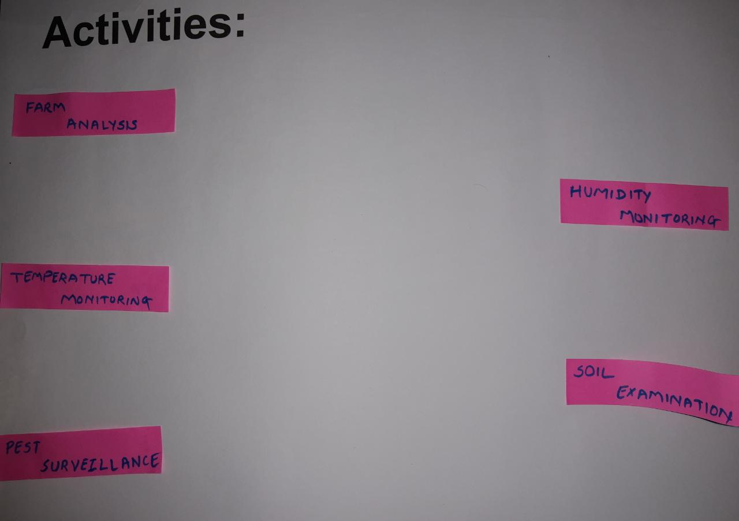

**Activities**

##### Environment: -

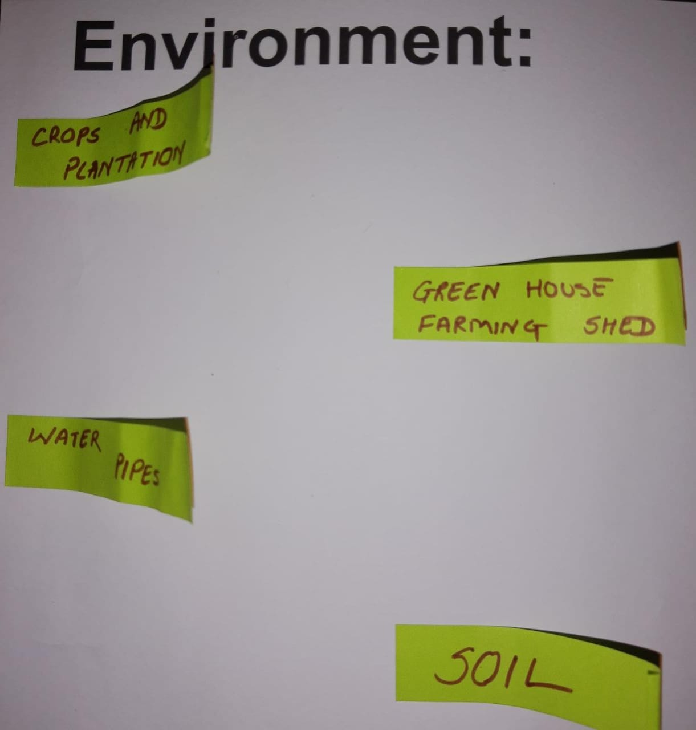

**Environment**

##### Interaction: -

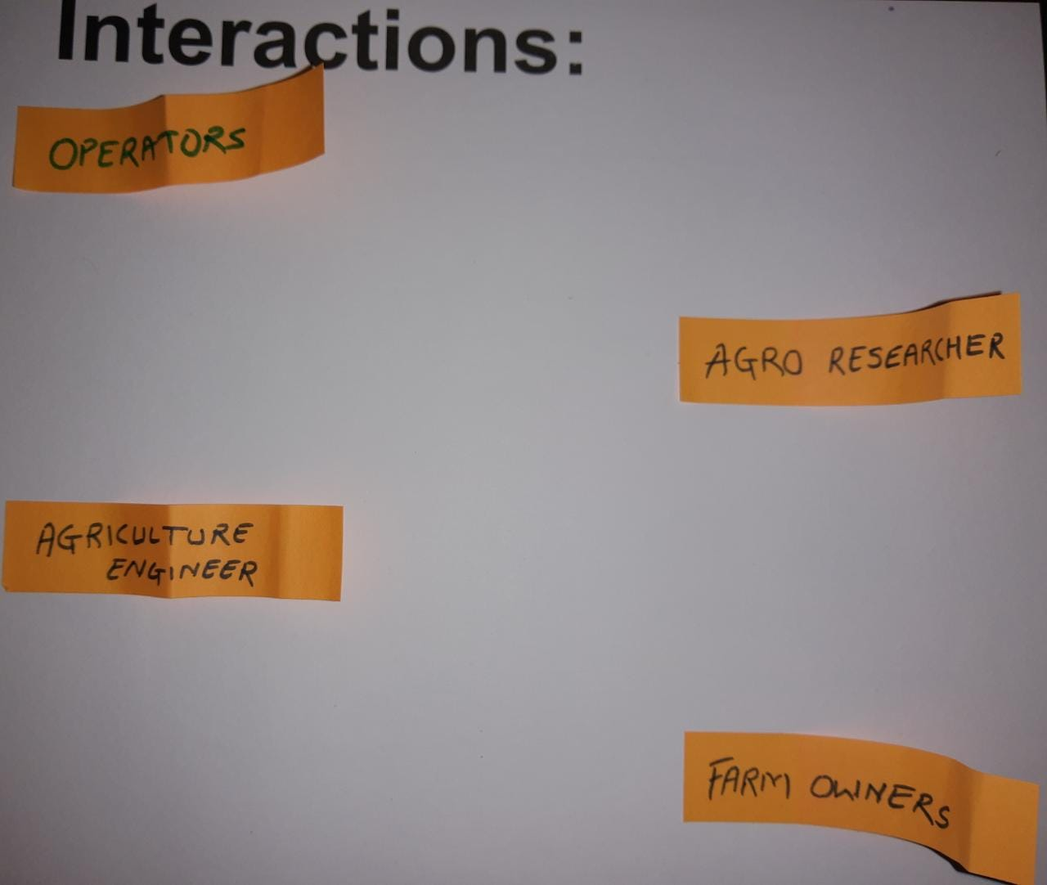

###### Interactions

##### Objects: -

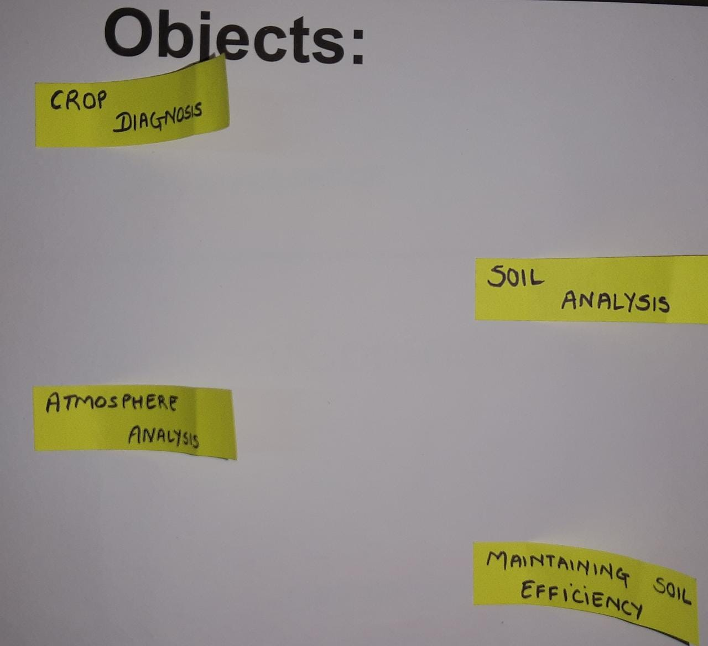

##### User: -

##### 

**Users**

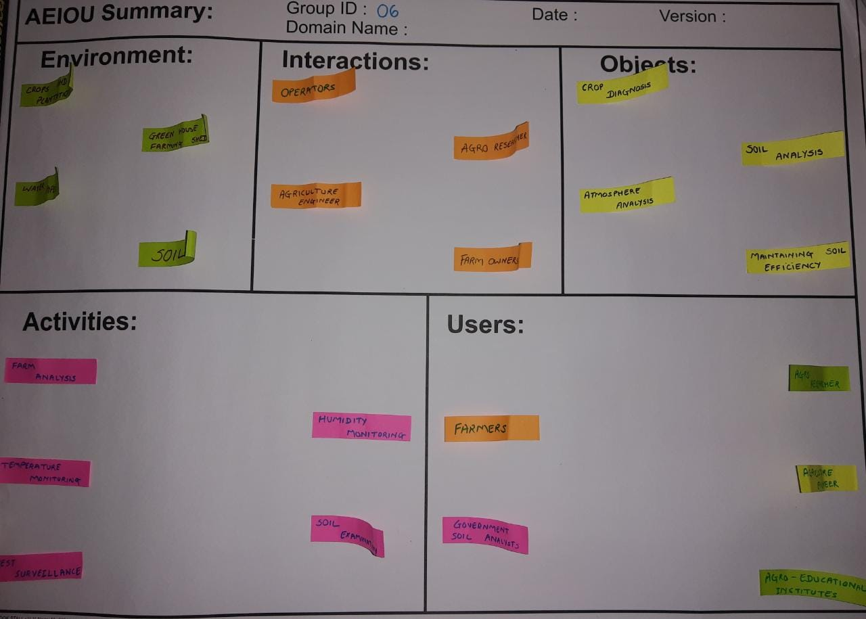

**AEIOU canvas**

* 1. **Mind map**

What is mind map?

A diagram in which information is represented visually, usually with a central idea placed in the middle and associated ideas arranged about it.

Description-

We came to know about problem and through what ways we can easily overcome it. And we came up with an overview and formed a mind map.

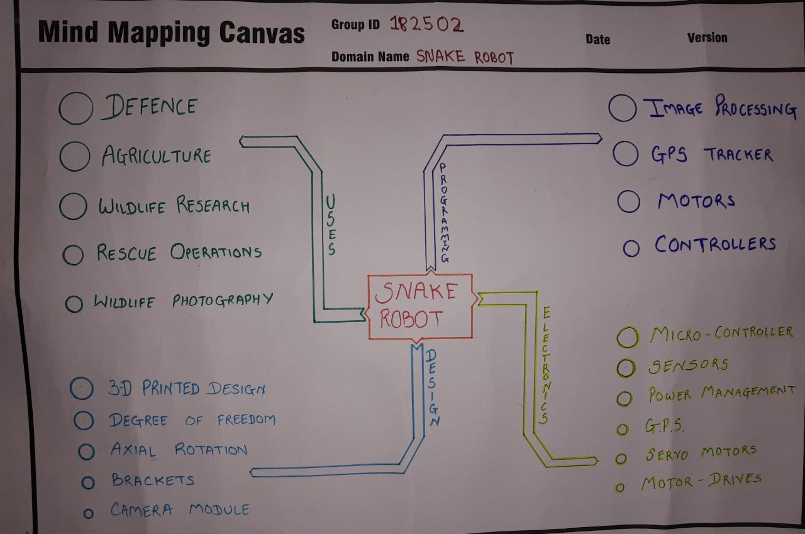

**Mind Map**

# Empathy mapping-

**3.1 USER**

Users here are Senior Citizen, Patient, Businessman & Student.

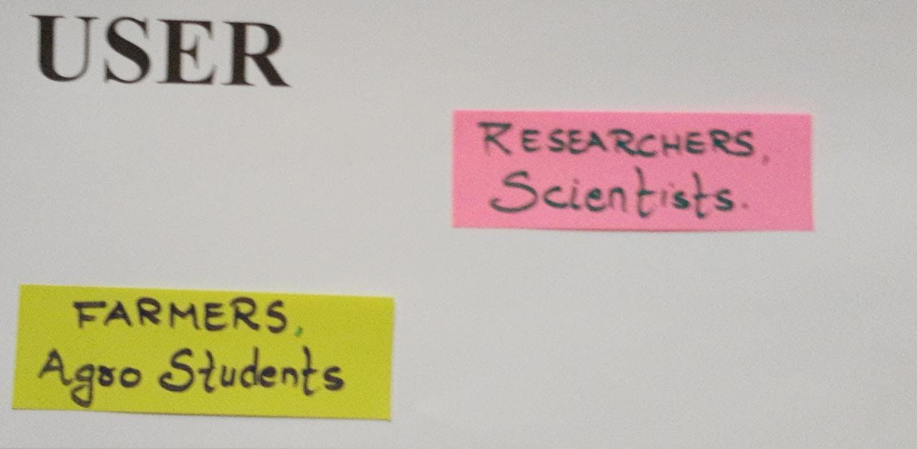

##### Stakeholder –

###### User

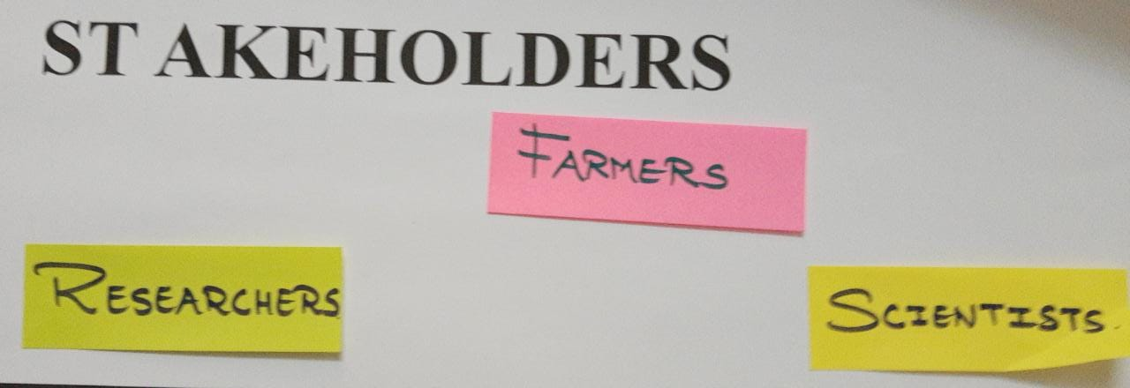

**Stakeholder**

**3.3 Activities -**

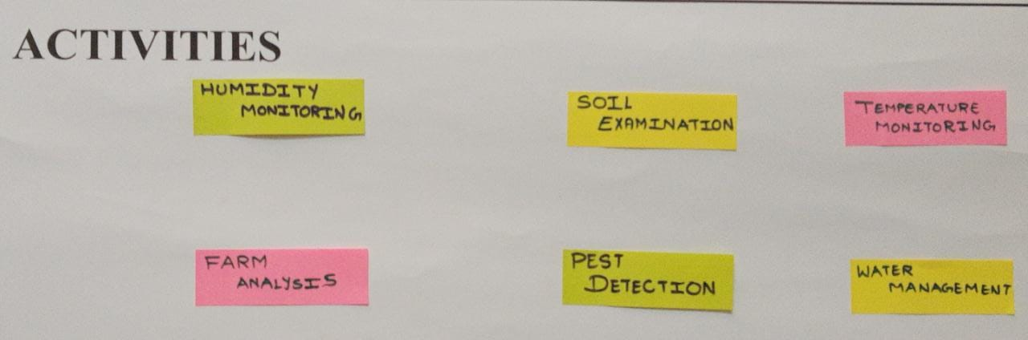

**Activities**

**3.4 Happy and Sad Story -**

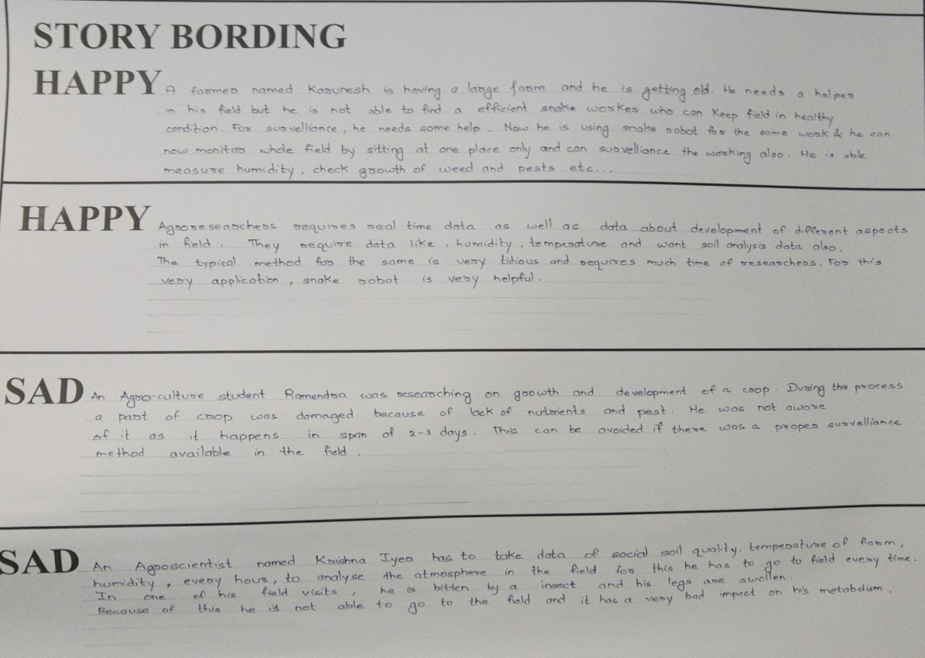

**Conclusion: -**

From this canvas we come to know about the problems various user and stakeholder faced.

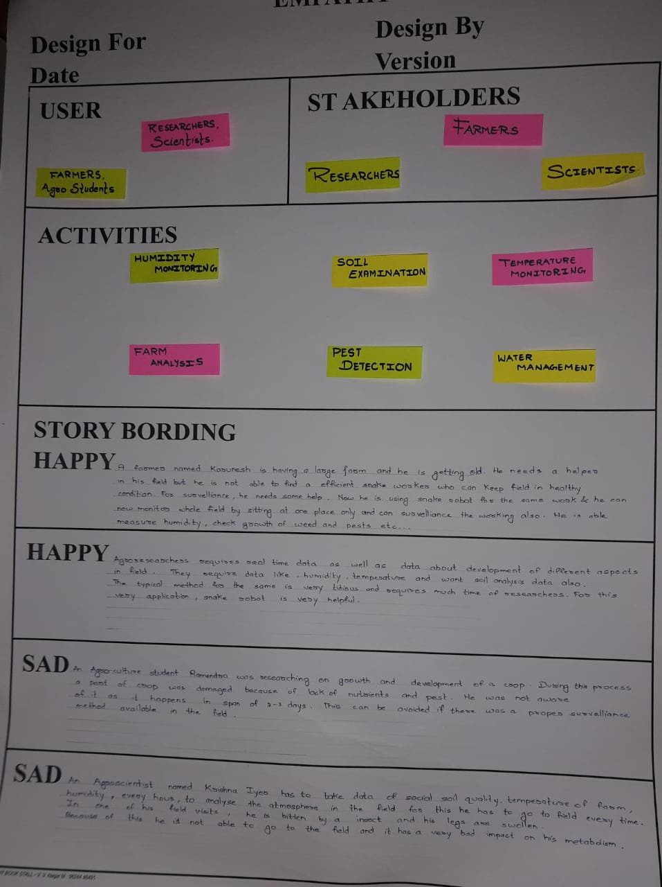

###### Empathy Canvas

# Ideation canvas: -

Ideation name only suggest creation of ideas. So, aim of Ideation canvas is to find the possible problems and to find out the ideas. Ideation canvas has 4 parts

People, activities, situation, props/object.

##### People

These are the persons who can use our product and they are as follows shown in figure.

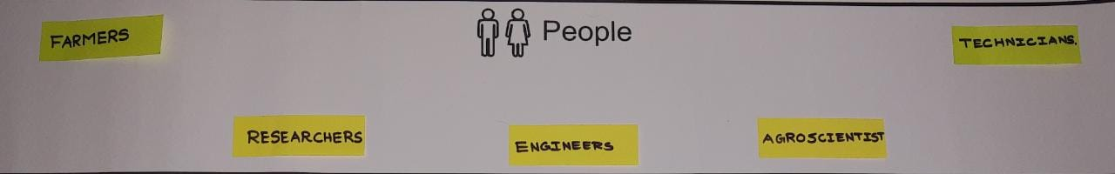

##### Activities

###### 

###### People

* 1. **ion/context /Location**

It is based on WHAT, WHY, WHEN, WHERE.

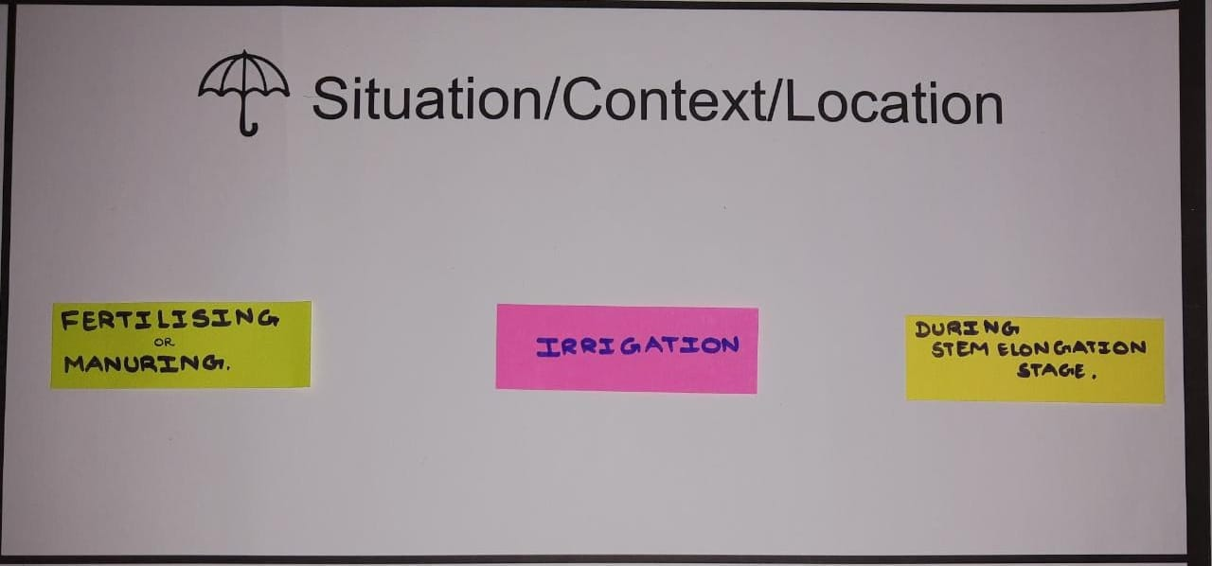

###### Situation/Context/Location

* 1. **Props/Tools/Objects/Equipment’s**

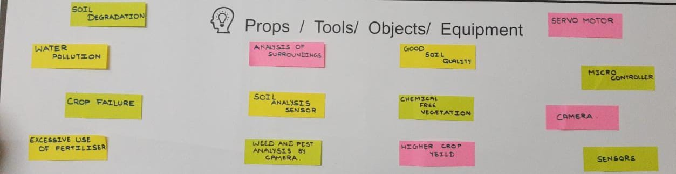

**Tools/Objects/Equipment**

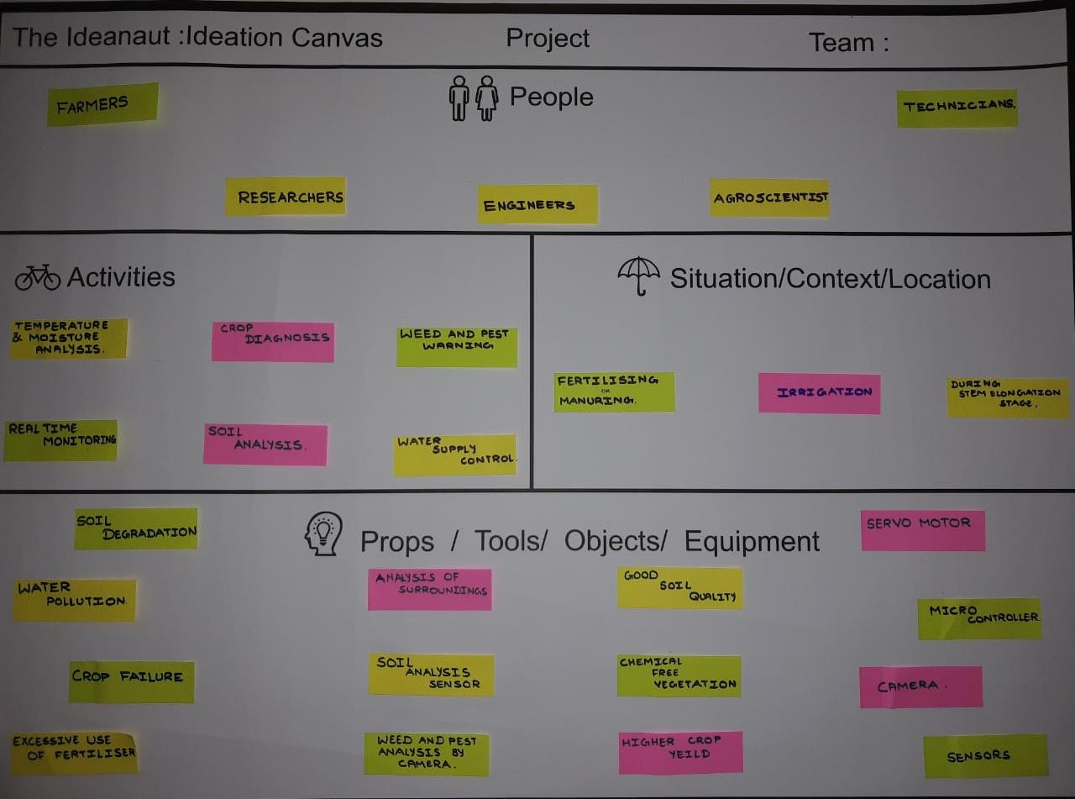

###### Ideation canvas

# Product Development Canvas

With a PDC all the relevant Information of a planning process can be clearly presented.

##### Purpose

What is the purpose of this concept you’re developing?

Dose it solves a problem, or it enhances a certain experience?

Is it serving a need, or it is trying to create a new need or tap an untapped need?

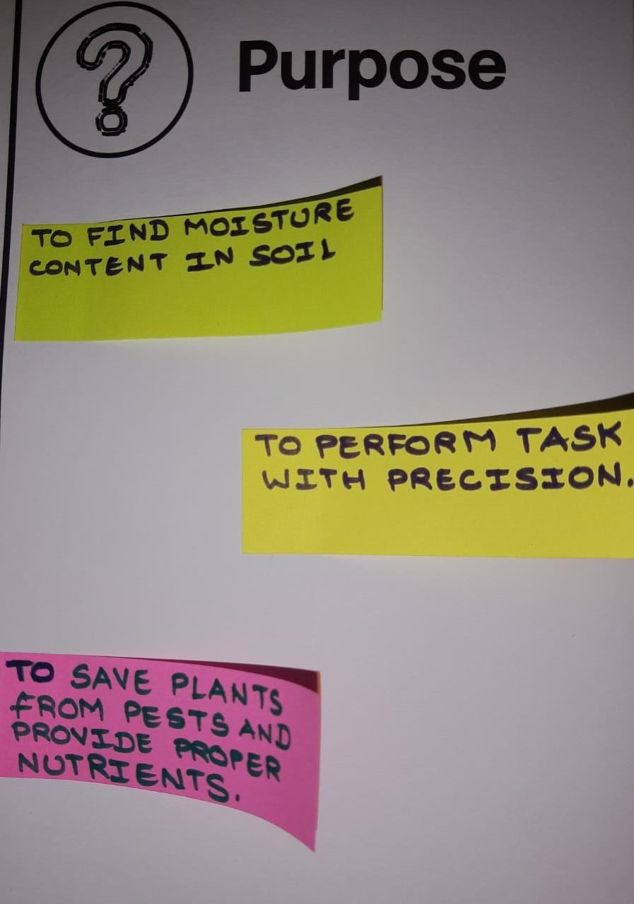

##### Purpose

##### People

-It includes people who use it.

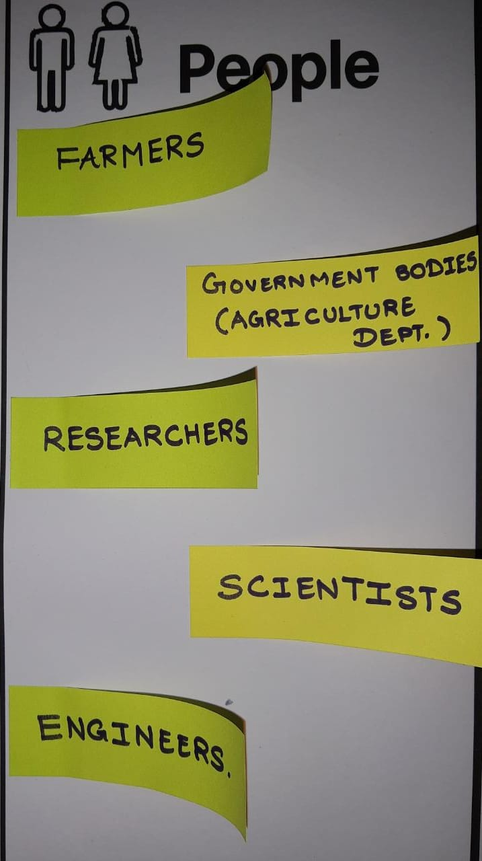

##### People

##### Product Features

Our product will have the following features-

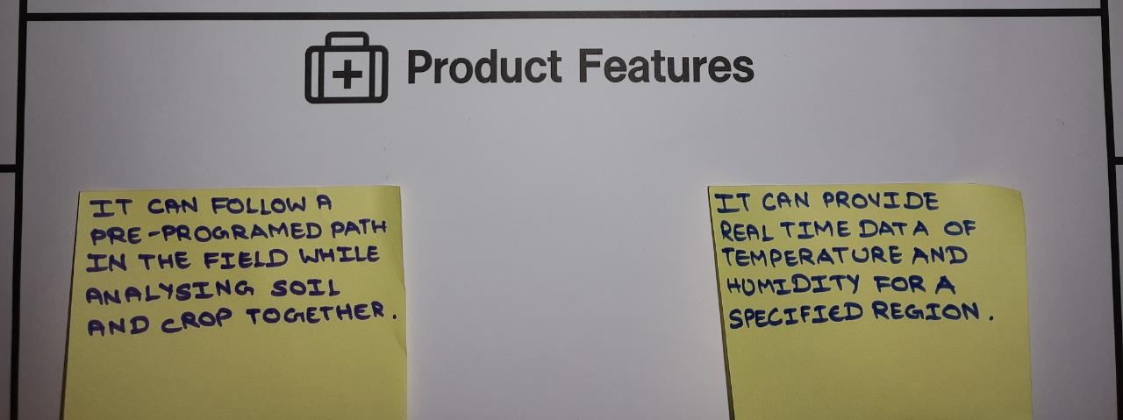

##### Product Features

* 1. **Functions-**

Our product will have the following function-

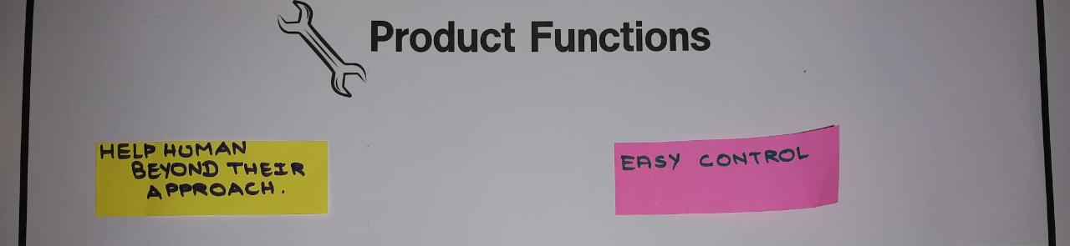

##### Product Function

* 1. **Components**

Our product components are shown in figure.

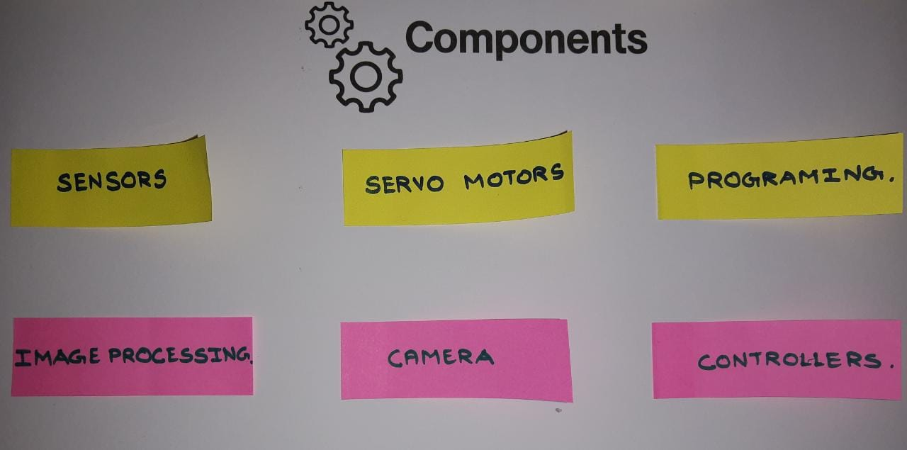

Further this is our ideation canvas: -

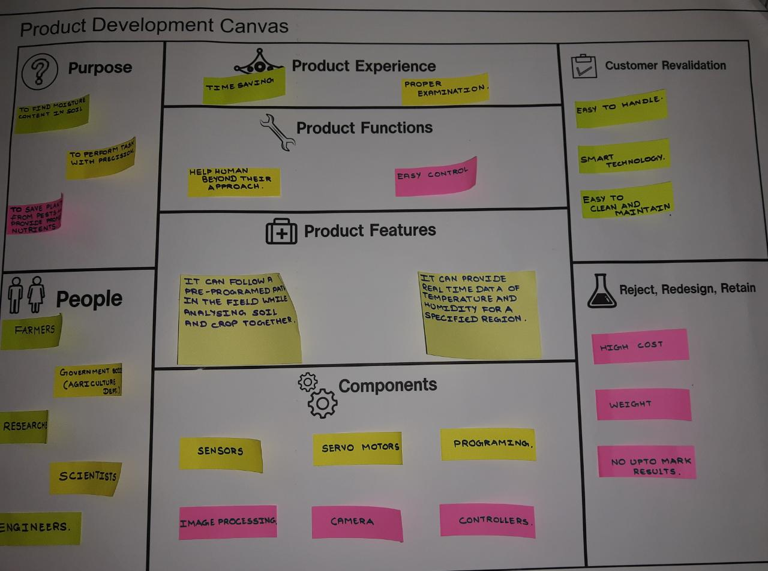

###### Product Development Canvas